**Perl On NetBeans**

**User Guide for version 0.1 (Beta)**

# Scope

Perl on NetBeans is intended for Perl programmers who want the intuitiveness of a great editor with the ease of being able to execute the program without having to do it through a Command Interpreter. Also, it has the capability to inspect the austerity of your Perl programs, and format the same in accordance to the best practices and conventions.

# Available features as of Beta

1. Perl File Type Support
2. Perl Project Type
3. Code Execution
4. Code execution with command line arguments
5. Syntax checking
6. Source code formatting
7. Source code analysis
8. Syntax highlighting (*incubating*)
9. Brace matching
10. Configuration using the Options Panel

# Pre-requisites

This IDE requires the following to be installed on your system for the IDE to work properly:

1. Perl v5.8 or greater
2. Java 6 or greater

# Installation

The installation of “Perl On NetBeans” can be summarized in the following steps:

1. Downloading the IDE from Google Code
2. Extracting the downloaded archive file to any location
3. Go to the extracted location -> *Perl On NetBeans v0.1 Beta (Win)\perl_on_netbeans\bin\ perl_on_netbeans.exe*

# Features

The IDE currently just has the following features.

1. Start-up

Once the project is downloaded and extracted, you need to go to the folder **perlonnetbeans/bin** and use the **perlonnetbeans** executable. The start-up screen is as shown below:



Figure 1 : The splash screen

1. New Project

To create a new project, click on the “**New Project**” icon on the toolbar or select “**File -> New project**”.The following screen is displayed:  
  
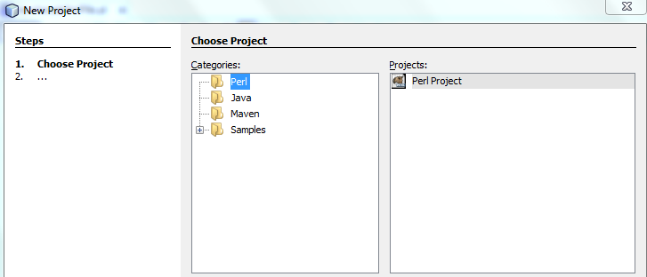

Figure 2 : Creating New PERL Project

Select “**Perl**” in the category and “**Perl Project**” under “**Projects**”. The subsequent screen will ask for the location where you want the project to be saved and will create a folder by that name with the project sources. The IDE will also open the project for further activities.

1. Open Project

To open an already existing project, select the “**Open Project**” icon in the toolbar or go to “**File -> Open Project**”. This opens up the project selection dialog box and enable you to select am existing Perl Project to be opened. Perl project have been assigned a different icon to distinguish them from other kinds of projects, as shown below.

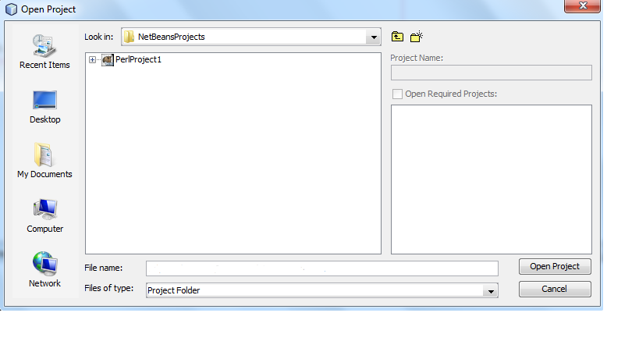

Figure 3 : Opening an existing PERL Project

1. New File

A new file can be added to any project by Right Click on the project node and then by selecting “**New -> Other**” as shown below.

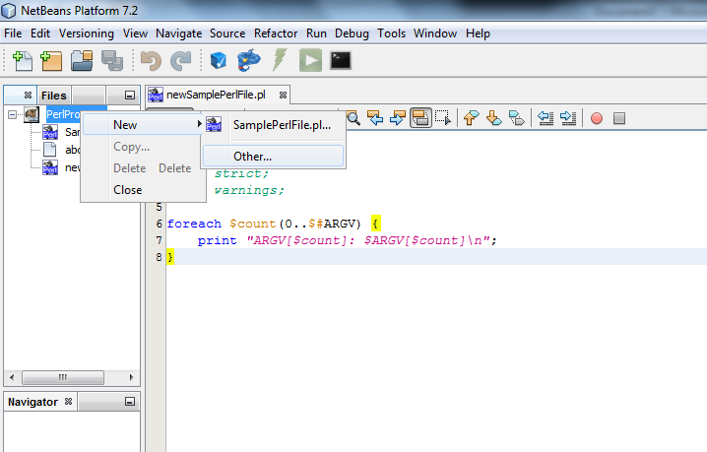

Figure 4 : Adding a new PERL file to project

This opens-up the subsequent window for selecting the file type and locations. Select the “**Perl**” category and then select “**SamplePerlFile.pl**” as the file type.

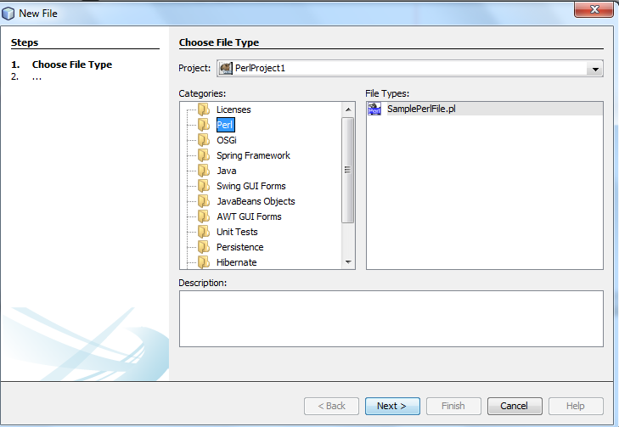

Figure 5 : Selecting the file type3to be added

Figure 6 : Selecting the File type to be added

The subsequent windows will ask for the location where the files should be saved. This should be ideally left on the IDE to decide as it selects the code folder automatically.

1. Check Files for Syntax Errors

This feature enables you to check the syntax of the file that is currently selected in the editor. To execute any specific file that is currently selected in the editor, click on the “**Syntax Check**” button on the toolbar as shown below. This checking happens based on the version of the Perl compiler that is currently installed on your system.



Figure 7 : Toolbar icon to check for syntax errors in selected PERL file

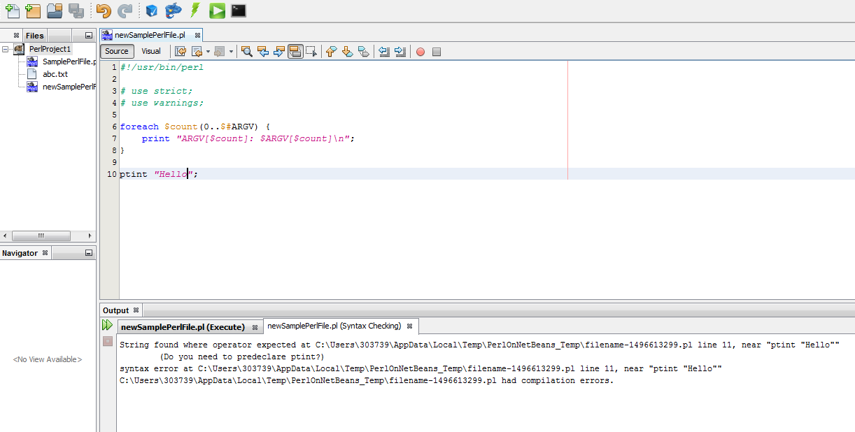

Figure 8 : Syntax checking results

1. Execute Files

This feature enables you to execute the file that is currently selected in the editor. To execute any specific select it in the editor and click on the “**Execute**” button on the toolbar as shown below. This execution happens based on the version of the Perl compiler that is currently installed on your system or selected from the options panel (*described below*).

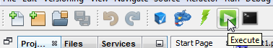

Figure 9 : Toolbar icon to execute selected PERL file

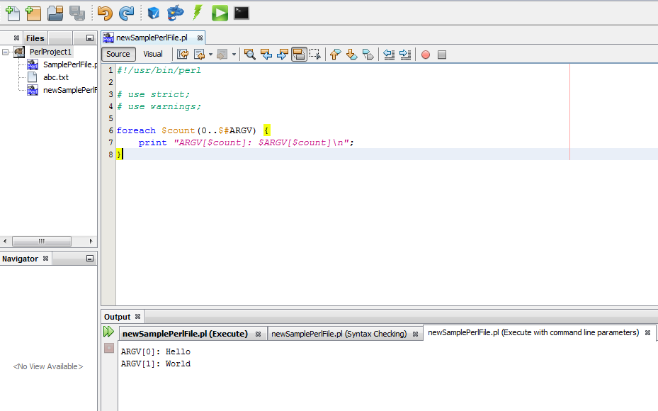

Figure 10 : Execution results

1. Source Code formatting

This feature enables you to perform source re-formatting as per **Perl::Tidy**. To perform analysis, select the file in the editor and click on the code formatter button on the toolbar as shown below. This will run the source code formatter against the selected source.

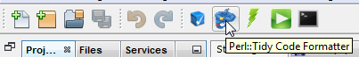

Figure 11 : Toolbar icon to format selected PERL file

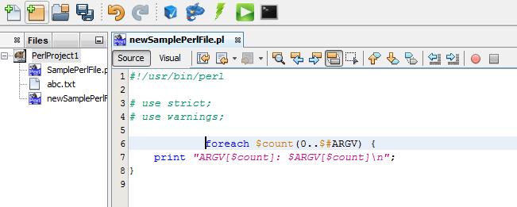

Figure 12 : Code formatting (Before)

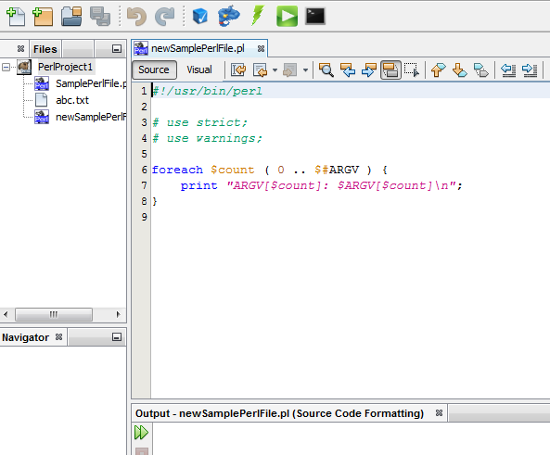

Figure 13 : Code Formatting (After)

1. Source code analysis

This feature enables you to perform source analysis as per **Perl::Critic**. To perform analysis, select the file in the editor and click on the code analyzer button on the toolbar as shown below. This will run the source code analyzer against the selected source.

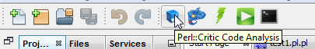

Figure 14 : Toolbar icon to analyze source code of selected PERL file

The output of the analysis will be provided in the Output window, as shown in the screenshot below:  
  
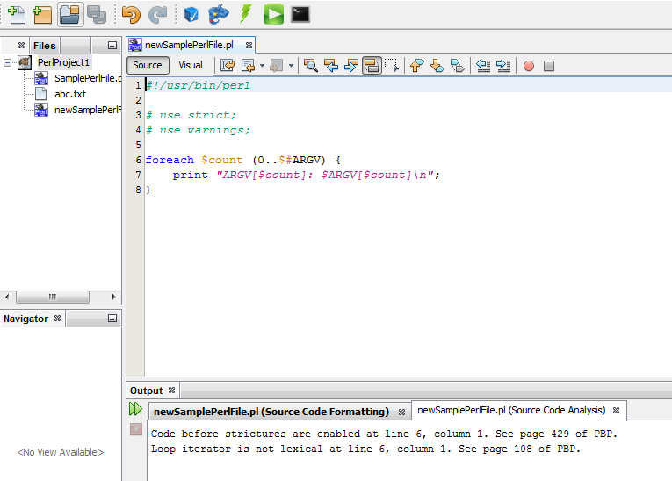

Figure 15 : Source code analysis results

1. Code execution with command line arguments

The latest release allows one to supply command-line argument(s). To execute a file with command line options, select the file in the editor and click the “**Execute (with command line options)**” button on the toolbar as shown below. On using this feature, a dialog box pops up, in turn facilitating the input of command-line parameters to be used in one’s program.



Figure 16 : Toolbar icon to execute selected PERL file with command line arguments

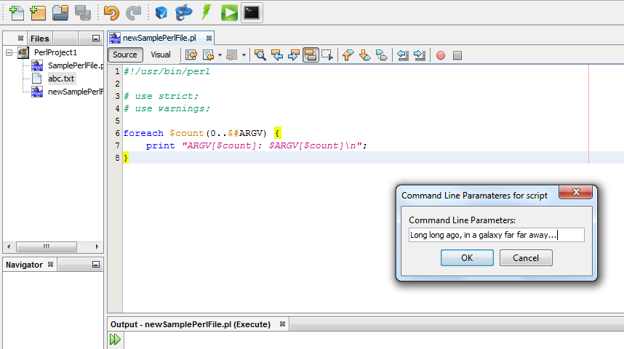

Figure 17 : Providing the command line arguments

Subsequent Execution of the script

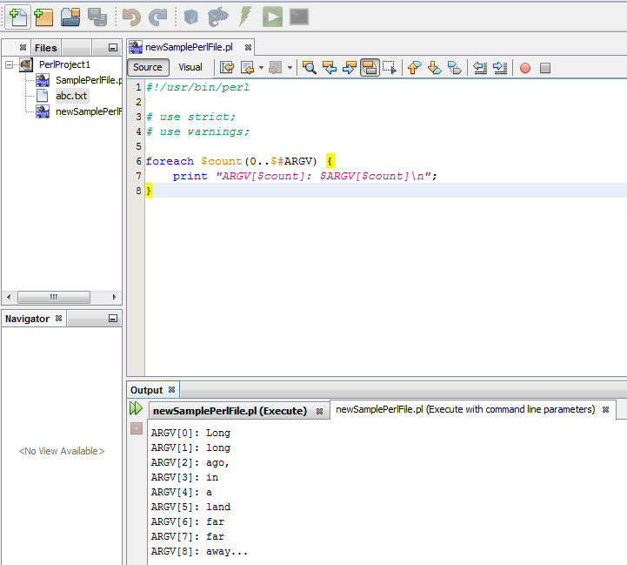

Figure 18 : Results of execution with the command line arguments

1. Options Panel

The Options Panel contains a section called “Perl On NetBeans” for our usage. This tab contains 3 sub-tabs that are utilized for various options.

1. General

This tab contains the option to over-ride the default PERL installed on your machine. Let’s say that you have PERL 5.14 installed on your machine as the default but you want to use PERL 5.16 available at a non-default location, you can point the perl.exe binary using this tab and your program will be operated on by the executable specified here. If you do not specify anything here, the default PERL will be used.

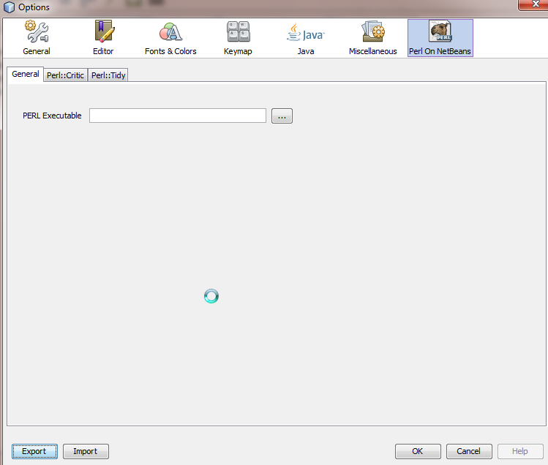

Figure 19 : PERL binary configuration panel

1. Perl::Critic

This tab can be used to customize the code analysis options. For a complete meaning of the options here, please refer to the URL <http://linux.die.net/man/1/perlcritic>. Please note that all the features mentioned on the URL are not available now.

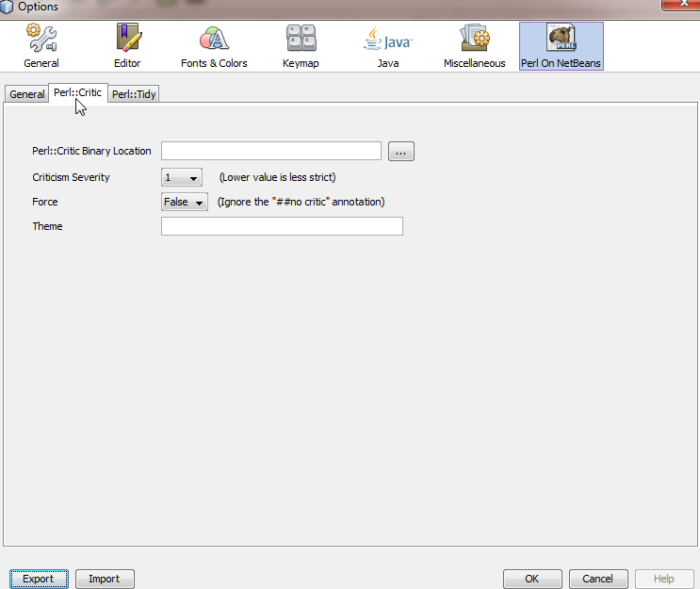

Figure 20 : PERL::Critic (Code Analyzer) configuration panel

1. Perl::Tidy

This tab can be used to customize the code formatting options. For a complete meaning of the options here, please refer to the URL <http://perltidy.sourceforge.net/perltidy.html>. Please note that all the features mentioned on the URL are not available now.

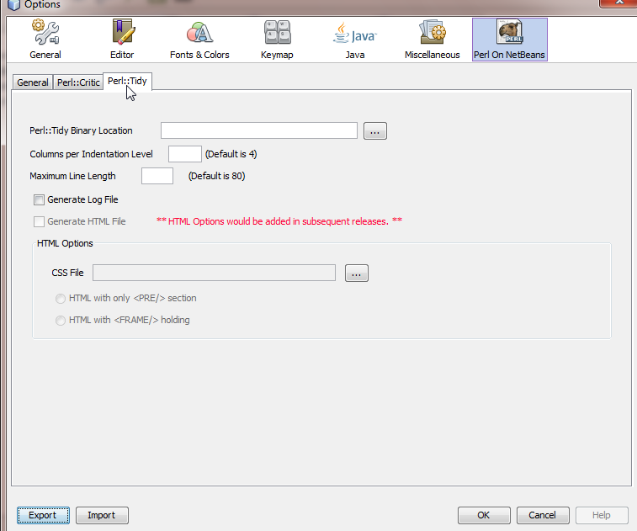

Figure 21 : PERL::Tidy (Code Formatting) configuration panel

# Feedback

Since this is a community driven initiative, I would request everyone to log-on to my Google Code space for downloading the IDE. Also for any issues, please do log an issue with Google Code on my project space. And for any comments/suggestions, please do send a mail to my Google Groups group-id as mentioned in the “Web Links” section below.

# Web Links

1. My Google Code space – <http://code.google.com/p/perl-on-netbeans>
2. Perl On NetBeans user group – <http://groups.google.com/group/perlonnetbeans>
3. Google Groups mail-id - [perlonnetbeans@googlegroups.com](mailto:perlonnetbeans@googlegroups.com)
4. FaceBook page: <http://www.facebook.com/PerlOnNetBeans>